2021 Family BEBRAS Challenge
SENIOR

As a family complete all 15 challenges, enter your family details and email your entry to luke.johnson@education.wa.edu.au. All complete entries will go into the draw to win the grand prize at Friday’s assembly. Remember COMPUTATIONAL thinking is about using strategies to solve a problem – and can be applied to any problem you face! Have fun, good luck and enjoy!

Family name
Students & Room

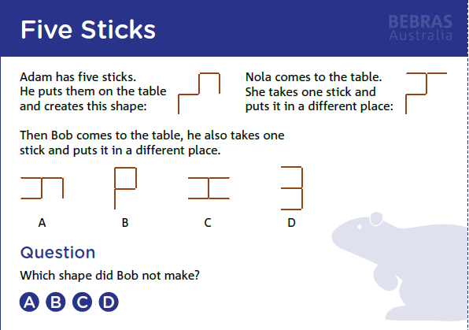
ANSWER:

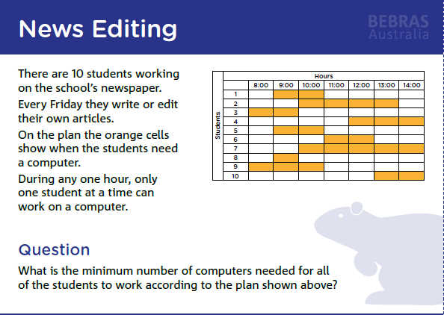
ANSWER:

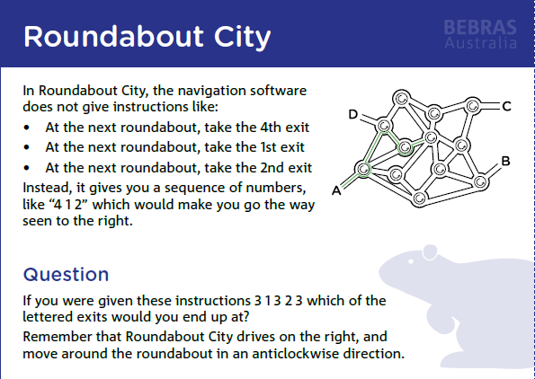
ANSWER:
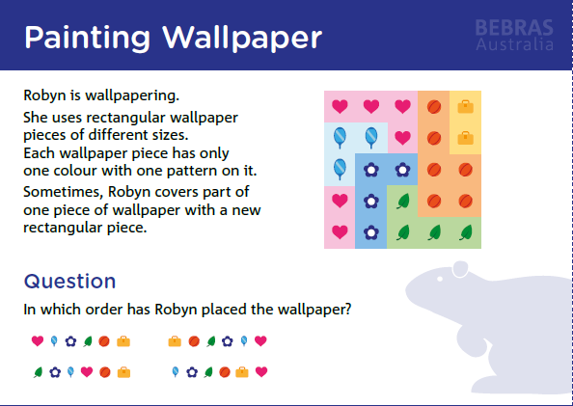
ANSWER:

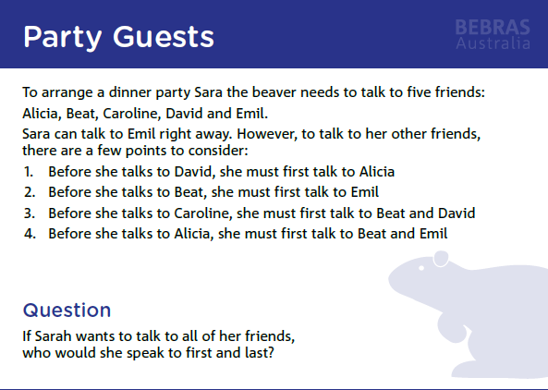
ANSWER:
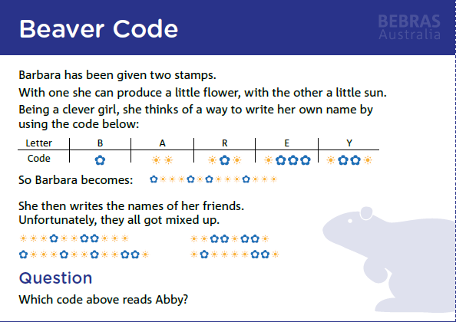
ANSWER:

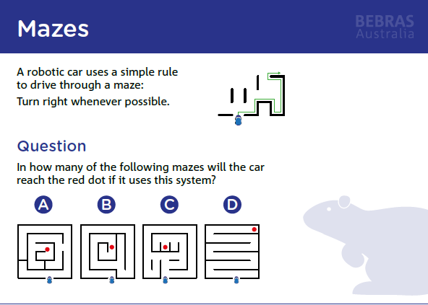
ANSWER:
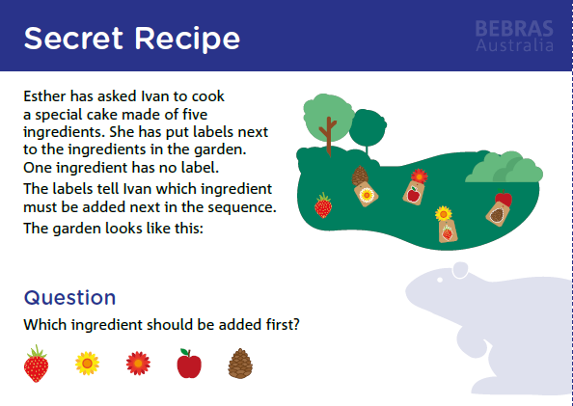
ANSWER:

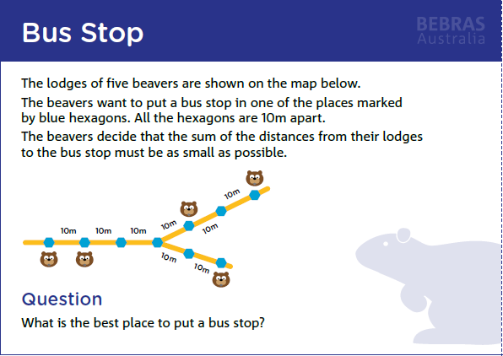
ANSWER:
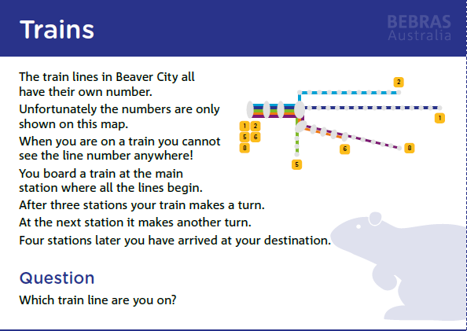
ANSWER:

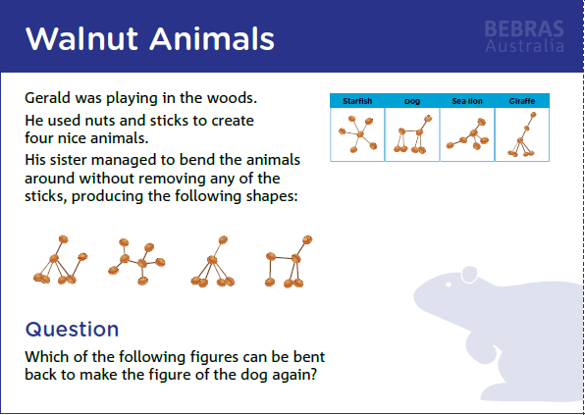
ANSWER:
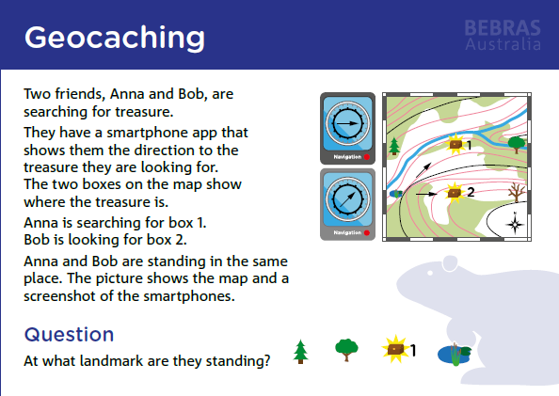
ANSWER:

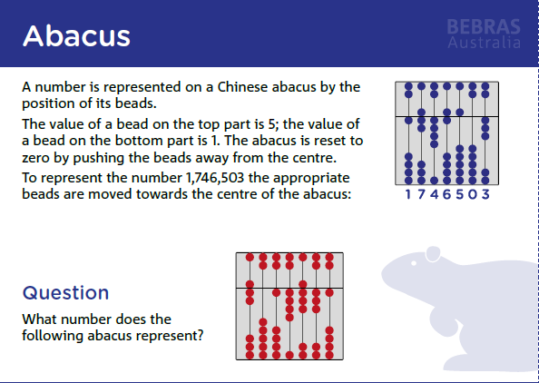
ANSWER:
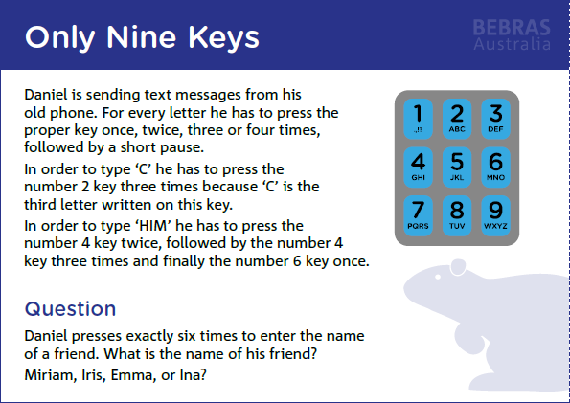
ANSWER:

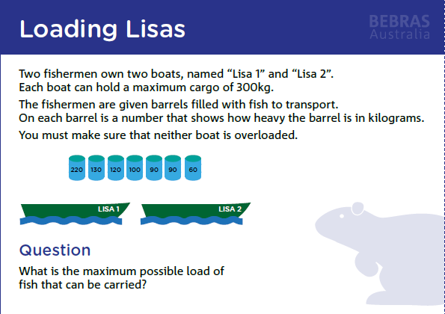
ANSWER:

