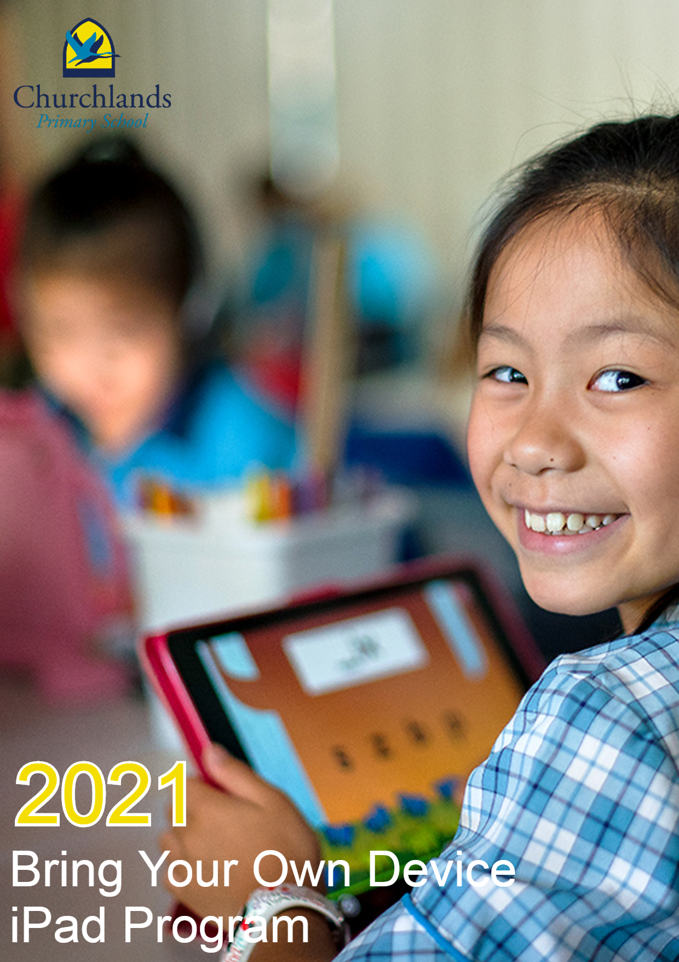

BYOD iPad Procedures & Guidelines

Rationale
The integration of digital technologies as an effective learning tool supports and enhances the teaching and learning program at Churchlands PS. Teachers incorporate digital technologies into learning and assessment to create environments focussed on developing creativity, problem solving and critical thinking. Churchlands PS develops responsible digital citizens who are accountable for their online behaviour and learning.

The Western Australian Curriculum mandates the integration of Information and Communication Technology (ICT) across all learning areas. By 2020 all Australian students will undertake the National Assessment Literacy and Numeracy (NAPLAN) tests online.

Effective use of digital technologies increases academic engagement and outcomes as well as equipping our students with a variety of necessary 21st century skills such as the 4 Cs (collaboration, creativity, critical thinking, and communication). These are all skills that will help our students thrive in today’s world and equip them with core competencies for the future. We believe in implementing new and innovative ways to help our students achieve our motto ‘Learning for life’.

Research Article

Longitudinal study on impact of iPad use on teaching and learning
Hui Yong Tay |Shuyan Wang (Reviewing Editor) Article: 1127308 | Received 24 Oct 2015, Accepted 30 Nov 2015, Published online: 18 Jan 2016

“…the findings present support for the previous studies that the use of the iPad results in greater learner engagement. The study provides an insight into the differentiated effect it can have on different ability groups. However, one hastens to add that it is not the device per se but how it is used to facilitate the deep learning that educators write about (Angelo, 2012Angelo, T. (2012, November 5). In other words, the technology is not used just as a device for students to find or display information. That would be using technology at a substitution, or at best, augmentation, level with no or little real-functional improvement from having information displayed on hard copy text (Puentedura, 2014Puentedura, R. P. (2014). To achieve the desired student outcomes, technology should be used in a transformational way to enable significant task redesign, even tasks previously thought inconceivable. In addition, technology should be used to enable “deep learning tasks characterized by exploration, connectedness and broader, real-world purposes” (Fullan & Langworthy, 2014Fullan, M., & Langworthy, M. (2014) The teacher’s role changes from focusing on covering content to focusing on developing the students’ ability to take charge of their learning. Indeed, it is when teachers are able to transform their roles and their lessons that we can harness the potential that technology offers in enhancing learning for our Digital Natives.”

CPS Pedagogy
The implementation of any technology program within a school must be based upon a sound pedagogical rationale. It is imperative that for any BYOD program to be successful teacher’s will need to have a sound understanding on how to equip our students with the core skills they need to become digitally literate. At Churchlands we encourage creation over consumption when using digital technology such as iPads. Churchlands Primary School has a number of strategies and programs in place to cater for the variety of learner needs within the school.

The Churchlands Primary School ICT vision states, “Our vision is to challenge students to use technology in ways which encourage collaboration, communication and creation over consumption. The effective use of technology can be transformational when put in the hands of responsible global citizens”

Critical to the success of the Churchlands PS 1:1 Bring Your Own Device (BYOD) program is the pedagogy used to create an environment that accommodates diverse student needs. At Churchlands PS, we acknowledge that the successful implementation of any technology program is reliant on quality professional learning linked to the Australian Professional Standards for Teachers. We will continue to ensure that professional learning around the implementation of BYOD iPads will provide:

- A strong focus on pedagogy first, technology second.
- Time for teachers to become familiar with devices and applications.
- The opportunity to attend formal professional learning sessions.
- Informal collaborations with other teachers.
- The support of an iPad mentor.

Mobile handheld technology has an inherent capacity to be personalised and when used in a 1:1 environment allows easy, sustained and consistent access for individual students. When students use their own personal devices it can also create links between learning at home and school. The introduction of BYOD is consistent with Churchlands Primary School’s Business Plan and the attainment of its goals.

The Substitution, Augmentation, Modification and Redefinition (SAMR) model offers a method of highlighting how computer technology can impact teaching and learning. It also shows a progression that adopters of educational technology often follow as they progress through teaching and learning with technology. ‘Substitution’ and ‘Augmentation’ - accomplish “traditional” tasks that have been enhanced by the use of technology. It is in the next two stages – ‘Modification’ and ‘Redefinition’ - where technology can be used to transform learning and involve rich, open-ended, student centred activities with a wider audience. All levels of the SAMR model are valuable in the learning process, however teachers are encouraged to plan activities in a sequence of learning that include technology enhanced learning from ‘Substitution’ to ‘Redefinition’. It is our belief, based on the current and emerging research that BYOD represents the next step in the transformation of our educational context from one in which technology merely supports the initial stages of learning to one where students are authentic participants and co-creators of knowledge, skills and values.

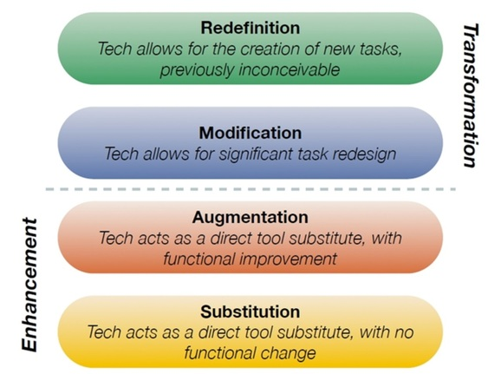

Technology Considerations
The 1:1 program will require students to own their own iPad for use at school and home. The prices listed below are from our iPad supplier, JB HiFi, who are offering discounted pricing for Churchlands PS parents through their unique Churchlands PS portal.

Bring Your Own Device Price Guide
* Prices dependent on place of purchase
Item | Cost
iPad 10.2” Wi-Fi 32GB | $439.00
Paid Apps for use in the classroom | ~$15 first year, $10 following years
iPad Case | $48.95
Optional Additions  - Apple Care | $79.00 (optional)
Total Cost | $502.95

Families are free to make their own decisions about where to purchase their iPads. JB HiFi and Winthrop have special offers to buy through their portal for Churchlands Primary School families.

  You may purchase your iPad via JB HiFi using our school code CLPS2021 at http://jbeducation.com.au/byod |   You may purchase your iPad via our unique parent purchasing portal through Winthrop using code Churchlandsps2021! Australia at https://sales.winaust.com.au/shop/churchlandsps

All iPads need to have a robust cover and be an iPad capable of running the latest iOS software. We ask that all families keep their iPad iOS current by regularly updating to the latest iOS firmware.
WiFi Only Option
We recommend the WiFi only models, as there are no re-occurring monthly charges since the devices can only use available wireless networks. While at school, the WiFi devices will be able to access the school network. We do not recommend purchasing the 3G/4G enabled iPads as you will be enabling your child to have connectivity via a mobile phone plan. If your child brings a 3G/4G enabled iPad to school, we will require that the 3G is turned off and that only the WiFi is used while on school grounds.
Hard Drive Size
The school recommends the 32 GB model, however it is up to the family to determine which size iPad to purchase.
Equity
If you have difficulty meeting the costs involved in this program, please contact the Principal to discuss the matter. As a public school we are committed to ensuring every child has access to a device regardless of the family’s financial position. A limited number of school managed iPads will be available for students to use at school should a family choose not to participate in the program. These iPads will be kept at school overnight.

Set up
All iPads need to be set up with an Apple ID. We recommend using Family Sharing to create these child accounts under an adult Apple ID in which you already own or setup for yourself. A ‘how to’ guide for parents in this set up can be found at support.apple.com by searching ‘Family Sharing and Apple ID for your child’. It is also recommended to enable iCloud backup in the Backup section found on the iCloud tab in Settings to ensure that data is regularly saved when the iPad is plugged in, locked and connected to Wifi.

Classroom Readiness
iPads are intended to be used at school each day, and therefore students are responsible to bring their iPad, fully charged, unless specifically instructed not to do so by the teacher. Although iPads are personal devices, academic content and apps take precedence over personal files, music, photos, and all non-educational apps (including games). Home apps should ALWAYS be stored in a clearly labelled ‘Home’ folder, and not accessed at school at any time.

Insurance
BYOD iPads are not covered by school insurance and we recommend you insure your device.

Health and Safety
Each year students, parents and teachers sign a three-way partnership agreement which covers items such as appropriate use at school and home, non-use of gaming and social media apps at school, use of other students devices etc. This agreement is seen as a contract between the three parties to ensure that all students’ safety online is the number one priority. This will need to be signed by all three parties by week 3 in term 1. There is a general internet usage agreement that will also need to be signed.

During the school year Digital Citizenship, which includes cyber safety, is addressed as part of 'Personal, Social and Community Health' in the Health and Physical Education curriculum and the Digital Technologies curriculum. It is important that students are equipped with the knowledge and strategies to protect themselves when interacting online. Ongoing education about cyber safety and how to be a responsible digital citizen are an integral part of the 1:1 BYOD iPad Program.

Screen Time
Children are spending more time with screen media -- and at younger ages -- than ever before. But there really is no magic number that's "just right." The idea of screen time as a one-dimensional activity is changing -- the American Academy of Pediatrics (AAP), whose screen time rules had been strictly age-based, is recognizing that not all screen time is created equal. Computers, tablets, and smartphones are multipurpose devices that can be used for lots of purposes. Designating their use simply as "screen time" can miss some important variations. The Common Sense Census identifies four main categories of screen time.
  - Passive consumption: watching TV, reading, and listening to music
  - Interactive consumption: playing games and browsing the Internet
  - Communication: video-chatting and using social media
  - Content creation: using devices to make digital art or music

Source: Common Sense Media - How much screen time is OK for my kid(s)?

Teachers at Churchlands Primary School focus their efforts on creating lessons where the main aim is content creation; with screen time is to be carefully considered when teachers are planning units of work. There is no defined maximum or minimum time-limits imposed onto any teaching tool usage – including iPads, as teachers use their professional judgement when selecting the most appropriate learning tools for each planned lesson. Churchlands Primary School teachers are, however, aware of risks when using technology and employ best practices to ensure that student activity is balanced and all available precautions are in place for safe and engaging use.

Ergonomics
Tablet use is associated with a ‘high degree of flexion’ in the head and neck; 1525° beyond a neutral, relaxed posture. This increase will quickly lead to fatigue and discomfort, and over time, injury. By elevating the device and avoiding lap level locations students can minimise any associated risks. This advice is supplied by The Harvard School of Public Health. Our teachers are aware of the need for good posture whilst using devices in the classroom. We have spent considerable time training our teachers on the correct posture for using devices. Tips supplied by the University of Oxford include:

Correct Posture
- Adopt a good sitting position in order to avoid straining your arms
- Do not slouch, sit forward or crouch over the iPad; sit up straight with the lower back supported
- iPads are not designed for prolonged use
- Work on a stable base and not on your lap
- Take regular breaks, especially to reposition the head and neck, and to rest the eyes

Internet Filtering
Internet traffic is filtered by the Department of Education’s filter system. However it is recommended that parents and caregivers enable the restrictions tab in settings to disable features that are not relevant for your child such as Messages or Facetime and disabling the play of explicit content in the music tab. Please note that there are no internet filters that are 100% effective. The use of social media including any messaging is not permitted during school hours (including parent to child messaging). The user agreement negotiated within classrooms includes consequences for misuse of technology. Education will be provided for children on processes to follow when they encounter inappropriate material.

In the school’s agreement usage policies and student agreements, it is stipulated that ALL technology use is to be directly supervised by a staff member at all times, and students are required to use technology ONLY when selected and instructed by the supervising teacher. Students are not to access their device during break times or before or after school when on school grounds.

This policy extends to internet searching and students are required to obtain specific permission from the supervising teacher, including detail on what search terms are being used, when locating information. When accessing the wifi network at school, students use personal logins and passwords to ensure that their network history, including internet usage, is filtered and monitored by the Western Australian Education Departments network systems tools.

The Challenge of Technology at Home
Monitoring technology use at home can be a challenge. Here are some important tips to assist you with guiding your child on responsible device usage.

- Even when children seem to have good technical knowledge, their online behaviour still requires parental monitoring and guidance.
- Spend time online with your child – exploring what they get up to can be fun!
- Keep technology in a shared and visible place.
- Set rules, and do your best to stick to them!
- Discuss the amount of time they can spend on technology. Negotiate and persevere
- Keep a balance of ALL types of activities – social, physical, intellectual.
- Encourage reporting and engage in conversation about usage.
- Not all screen time is the same!
- Co-engagement (working together with technology)
- Learning content & context (is the task facilitating learning and thinking?)
- Seek advice and use your supportive network – other parents, teachers & online.

We feel it is vitally important for parents to share your children’s Digital Citizenship learning journey, and we encourage your active participation in the modelling and guiding of what is deemed responsible technology based behaviour. There are many available resources to help in this area, including https://www.commonsensemedia.org/ and https://www.esafety.gov.au/parents.



Screen Time App
The Screentime app, built into iOS, allows parents to assign time limits on general iPad usage and app types. Setting up Screentime is highly recommended to assist in managing your child’s home iPad time. Please find instructions and more information about the Screentime app here https://support.apple.com/en-au/HT208982.

As we encourage a learning partnership, please look out for communications on positive technology learning experiences and information, published regularly in the school newsletter and on the school’s website. If you have any queries or questions regarding the iPad program, please feel welcome to contact the school.

